WBU Technology Packet

Vivianna Reyes

June 15, 2020

BASC 1201
Best Academic Strategies for College

Rosemary Hendley

XXXXXXXXX

Wayland Baptist University
Campus

Table of Contents

Page #
WBU Email Account: WBU email message …………………………………… 3

Student Services: Student’s current term class schedule……………………….. 4

BlackBoard: Discussion Board prompt 1 response ……………….…..……….. 5

WBU Online Library:

- Book Request Form ………………………..………………………….. 6
- Article Request Form…………………..……………………………….. 7
- Discipline specific journal article “Abstract” …………….………….…. 8

WBU Email Account:
Initial Contact with Instructor WBU email Message

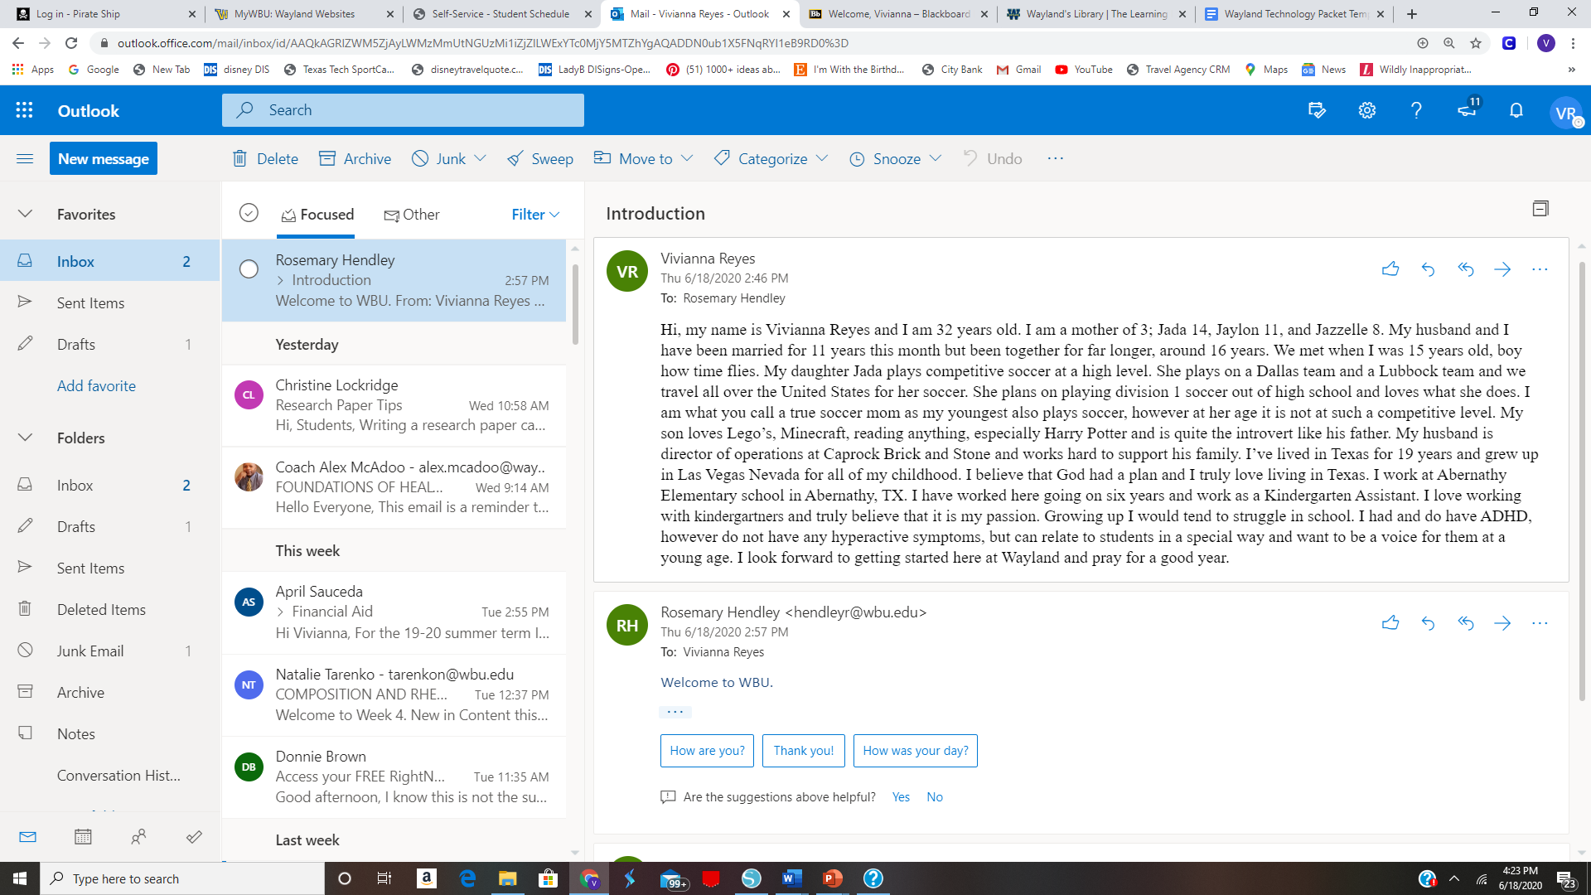

Student Services:
Student’s Current term class schedule

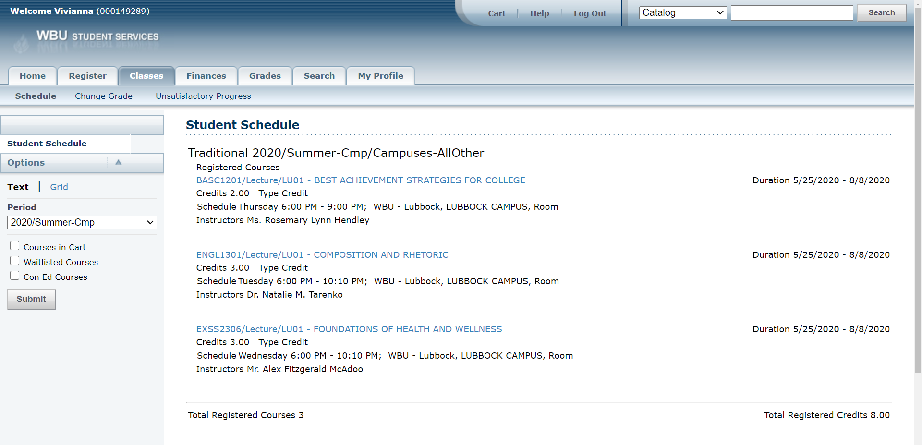

BlackBoard
Discussion Board Thread Prompt 1 Post
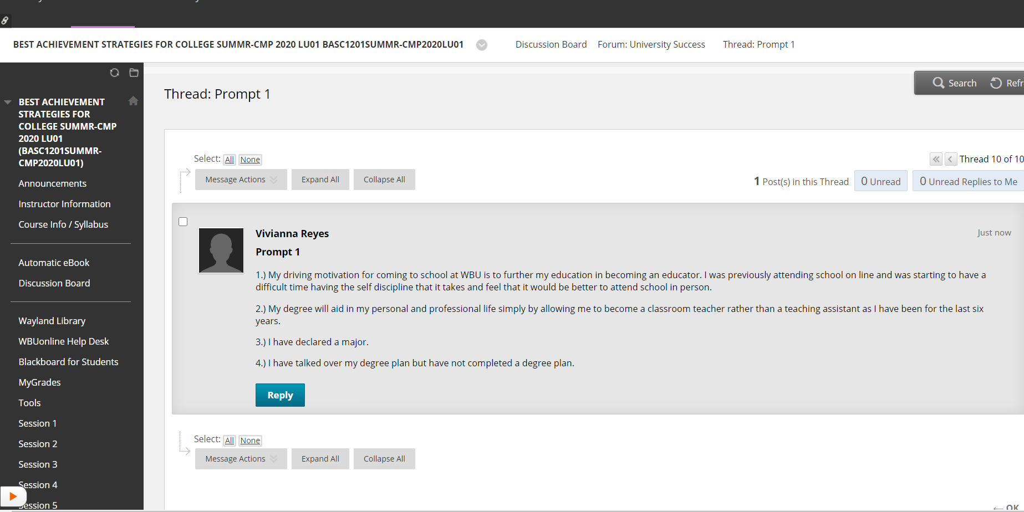

Book Request Form
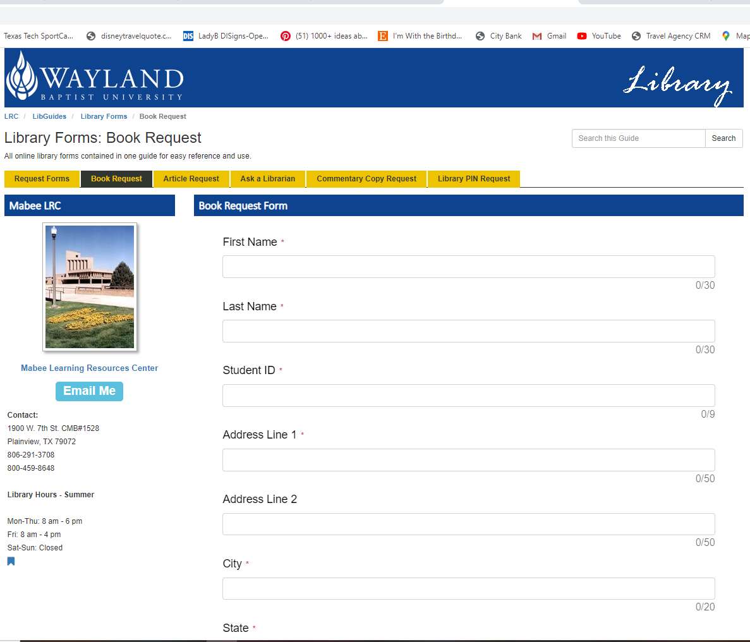

Article Request Form

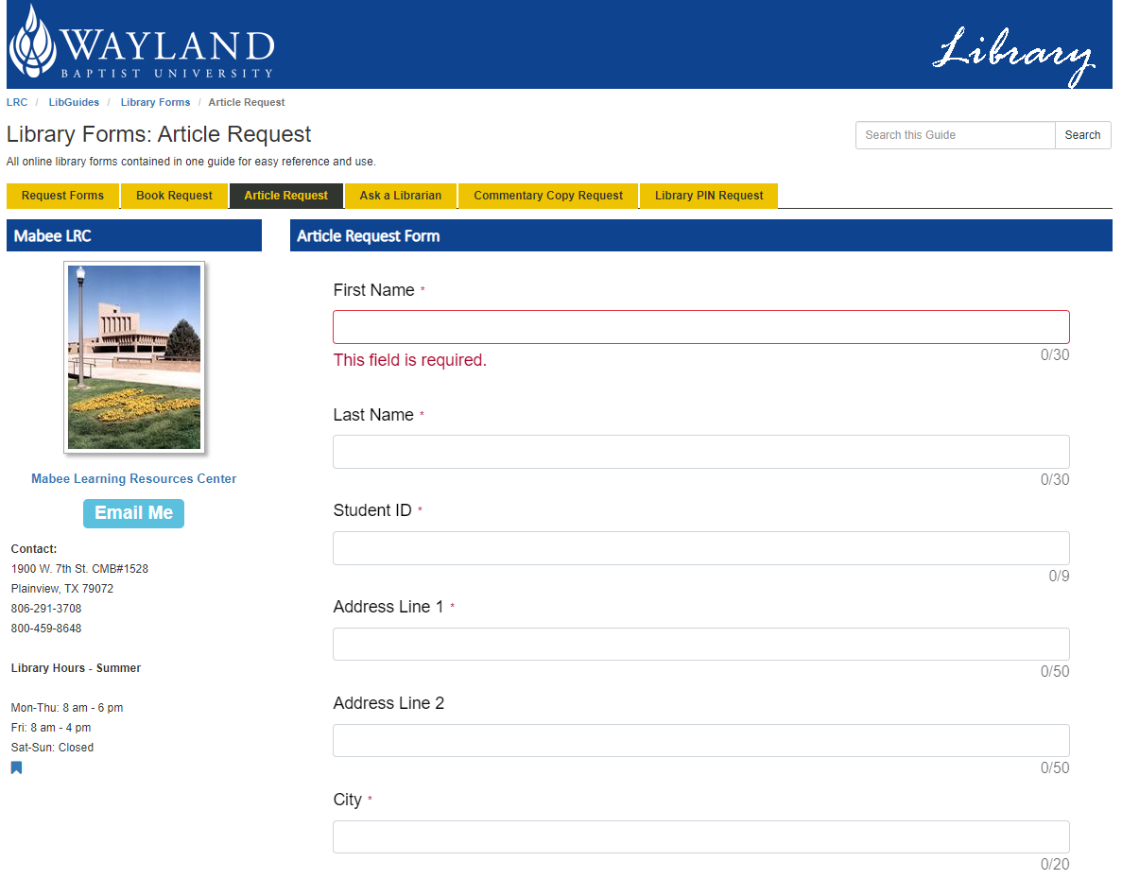

Discipline Specific JOURNAL “Abstract”

